Lab 03
Querying Company Database

MSSV:
Họ tên:

[Tên tập tin: Lab03_MSSV_HoTen.docx]

Queries
  - List the names of employees whose last name begin N character.
-- Cau 1
SELECT FName, LName FROM Employee
WHERE LName LIKE 'N%';
GO
-- Ket qua

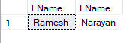

  - List employees whose sex is male and has address in Spring or Humble.
-- Cau 2
SELECT * FROM Employee
WHERE Sex = 'M' AND (Address = 'Spring, TX' OR Address = 'Humble, TX');
GO
-- Ket qua
  - Retrieve the names of project which does in Houston and managed by department 5.
-- Cau 3
SELECT PName FROM Project
WHERE PLocation = 'Houston' AND DNum = 5;
GO
-- Ket qua
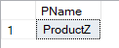
  - List dependents whose relationship is son and birth date is 1988 year.
-- Cau 4
SELECT * FROM Dependent
WHERE Relationship = 'Son' AND BDate = '1988';
GO
-- Ket qua
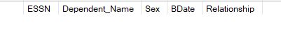
  - List the names of employees whose birth date is from 1940 to 1960, sex is female and salary is from 30000 to 50000.
-- Cau 5
SELECT FName, Mlnit,LName FROM Employee
WHERE (BDate BETWEEN '1940' AND '1960') AND Sex = 'F' AND (Salary BETWEEN 30000 AND 50000);
GO

-- Ket qua
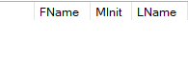

  - Find the names of employees that are directly supervised by 'Franklin Wong'.
-- Cau 6
SELECT * FROM Employee
WHERE FName = 'Franklin' AND LName = 'Wong';
GO
SELECT * FROM Employee
WHERE SuperSSN = '333445555';
GO
-- Ket qua
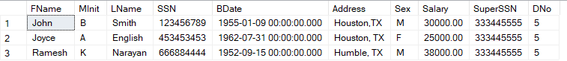
  - Retrieve the names of employees in department 5 who work more than 10 hours on the 'ProductX' project.
-- Cau 7
SELECT E.FName, E.Mlnit, E.LName
FROM Employee AS E, Project AS P, Works_On AS W
WHERE W.ESSN = E.SSN AND W.PNo = P.PNumber AND P.PName = 'ProductX' AND W.PNo = 1 AND Hours > 10 AND E.DNo = 5;
GO
-- Ket qua
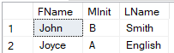
  - List the names of employees who have a dependent with the same first name as themselves.
-- Cau 8
SELECT E.FName, E.Mlnit, E.LName
FROM Employee AS E, Dependent AS D
WHERE E.FName = D.Dependent_Name;
GO
-- Ket qua
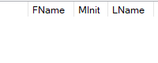
  - List the last names of department managers who have no dependents.
-- Cau 9

-- Ket qua

  - Retrieve the names of employees who do not work on any project.
-- Cau 1
-- Ket qua

  - Retrieve the average salary of all female employees.
-- Cau 1
-- Ket qua

  - For each department, retrieve the department name, and the average salary of employees working in that department.
-- Cau 1
-- Ket qua

  - For each project, list the project name and the total hours per week (by all employees) spent on that project.
-- Cau 1
-- Ket qua

  - Find the names and addresses of employees who work on at least one project located in Houston but whose department has no location in Houston.
-- Cau 1
-- Ket qua

  - Retrieve the names of employees who work on every project.
-- Cau 1
-- Ket qua

Note: Save to file Company_Queries.sql

